# **Dimensional Evolution: The Fractal Framework of Life via Resonant Perspective**

## **Title Page**

**Dimensional Evolution: The Fractal Framework of Life via Resonant Perspective***By Chuck Young*Submitted for consideration as a unifying perspective in physics, consciousness studies, and interdisciplinary science.

## **Abstract**

Dimensional Evolution (DE) reinterprets physical reality as a fractal resonance system between waveforms and their inverses. It proposes that particles, forces, biological life, and consciousness are not separate phenomena but standing wave interference patterns between an observable field (the "YouVerse") and its unobservable, entangled inverse (the "YouInverse").

Through this lens, DE explains unresolved mysteries in modern physics including:

* The true nature of gravity
* The mechanism of magnetism
* The role of consciousness in quantum collapse
* The origins of biological form and memory

DE introduces **dimensional gravity**, a force of tension between dimensions that replaces the need for unverified particles like gravitons or dark matter. This framework offers a profound reframing of quantum mechanics, general relativity, and molecular biology under one resonant principle. This paper presents not only a scientific model but a call to recognize the observer as a participant in the universe's evolution, and to embrace a new paradigm of reality: not as matter in space, but as resonance through consciousness.

## **Introduction**

Why should anyone care about another theory of everything? Because despite extraordinary advances in science, we still cannot answer the most essential questions about our universe—and ourselves. Why do galaxies rotate as if pulled by invisible mass? What exactly is a magnetic field? Why do quantum particles behave differently when observed? What force truly holds matter together across all scales? And perhaps most important of all—what role does consciousness play in any of it?

Mainstream physics has achieved breathtaking precision through models such as general relativity and quantum mechanics. But even with candidates like string theory, loop quantum gravity, and quantum field theory, we have yet to unify the forces of nature or resolve the paradox of the observer effect. Despite all we can calculate, we still do not know **what reality actually is**.

This paper introduces **Dimensional Evolution (DE)**—a framework that does not reject science, but completes it. DE proposes that reality itself is structured through resonance: a fractal interaction between an observed waveform and its entangled inverse. In this model:

* Matter is not substance but **interference**
* Gravity is not curvature but **dimensional tension**
* Consciousness is not emergent but **primary**

The value of this framework lies in its power to connect previously disconnected fields—physics, biology, electromagnetism, and consciousness—into one continuous resonance loop. DE fills the missing conceptual link between particle and wave, observer and observed, self and Source.

Through this lens, we will discover that what science has treated as mystery—quantum collapse, dark matter, magnetic induction, even the structure of DNA—are all expressions of a single pattern that does not require new particles or extra dimensions, but only a deeper understanding of **resonant perspective**.

You are not in the universe. **You are the universe—resonating with itself.**

This paper introduces **Dimensional Evolution (DE)**—a framework that does not reject science, but completes it. DE proposes that reality itself is structured through resonance: a fractal interaction between an observed waveform and its entangled inverse. In this model:

* Matter is not substance but **interference**
* Gravity is not curvature but **dimensional tension**
* Consciousness is not emergent but **primary**

The value of this framework lies in its power to connect previously disconnected fields—physics, biology, electromagnetism, and consciousness—into one continuous resonance loop. DE fills the missing conceptual link between particle and wave, observer and observed, self and Source.

Through this lens, we will discover that what science has treated as mystery—quantum collapse, dark matter, magnetic induction, even the spark of life itself—are all expressions of a single pattern. A pattern that does not require new particles or extra dimensions, but only a deeper understanding of **resonant perspective**.

**Dimensional Evolution begins with interference—and ends by revealing that both stars and conscious beings collapse into rebirth through the same harmonic law.**

## **Unresolved Mysteries in Science & Physics**

As science has evolved, it has revealed extraordinary insights—yet with every breakthrough, a shadow of unanswered questions has grown longer. Some of these questions are so fundamental, they ripple across every domain of physics and challenge our assumptions at every scale.

### **1. What Is a Magnetic Field?**

Magnetic fields are measured, manipulated, and essential to nearly all of modern technology—but physics still treats them as effects of motion or charge, not as entities with an origin or identity of their own. What is a magnetic field made of? Why does it exist at all?

### **2. What Is Gravity Really?**

Einstein's General Relativity beautifully describes how mass bends spacetime—but it doesn't explain what gravity *is*. Why does matter attract matter? Why can't gravity be unified with the other fundamental forces?

### **3. Why Do Galaxies Defy Gravitational Models?**

The motion of stars around galactic centers doesn't match predictions. Instead of re-examining gravity, science invented "dark matter" to fill the gap—but dark matter has never been directly observed.

### **4. What Is the True Role of the Observer?**

Quantum experiments show that particles behave differently when observed. The famous double-slit experiment suggests that observation collapses wavefunctions—but what exactly *is* observation? What causes collapse? Why is consciousness involved at all?

### **5. What Is Consciousness—and Why Can't We Find It in the Brain?**

Neuroscience maps patterns and regions of the brain, but cannot locate the experience of being—the internal awareness that observes, feels, and chooses. Science has tried to reduce consciousness to chemistry, but no equation yet explains the mind.

These are not just curiosities. They are signs that something deeper is missing—a layer of understanding that does not discard current models, but connects them. **Dimensional Evolution is that missing layer.**

## **The Particle-Wave Paradox in Quantum Mechanics**

One of the most puzzling and powerful discoveries in physics is the particle-wave duality. Quantum objects—like electrons or photons—can behave like particles or like waves depending on how they are measured. In the famous double-slit experiment, a single photon can appear to go through both slits at once—until it is observed. When observed, it behaves like a particle and "chooses" a single slit. This is not a problem of instruments. It's a problem of reality itself.

The standard quantum explanation is that particles exist in a *superposition*—a probability field—until observation causes the wavefunction to collapse into a definite state. But this raises a deeper question: **what is observation?** What counts as an observer? And why should *any* act of measurement alter the outcome?

Dimensional Evolution offers a radically simple answer: **there is no collapse**. The wave never ends. What we call collapse is simply the act of resonating with a slice of the wave field. Observation is not destruction—it is selection.

You, the observer, are not standing outside the wave. You are embedded within it. Your consciousness tunes to a slice of potential, and in that resonance, a third thing emerges: a point of experience—a new perspective. That new perspective is the YouVerse.

The particle is not a tiny ball flying through space. It is a **stable interference pattern** formed between your resonant perspective and the Source field of all potential. The act of observation is the creation of a shared standing wave—a pattern we call reality.

This realization flips the entire concept of measurement: it is not a passive reading—it is an **act of creation**. Every observation births a new frame of reference, a new echo in the fractal loop.

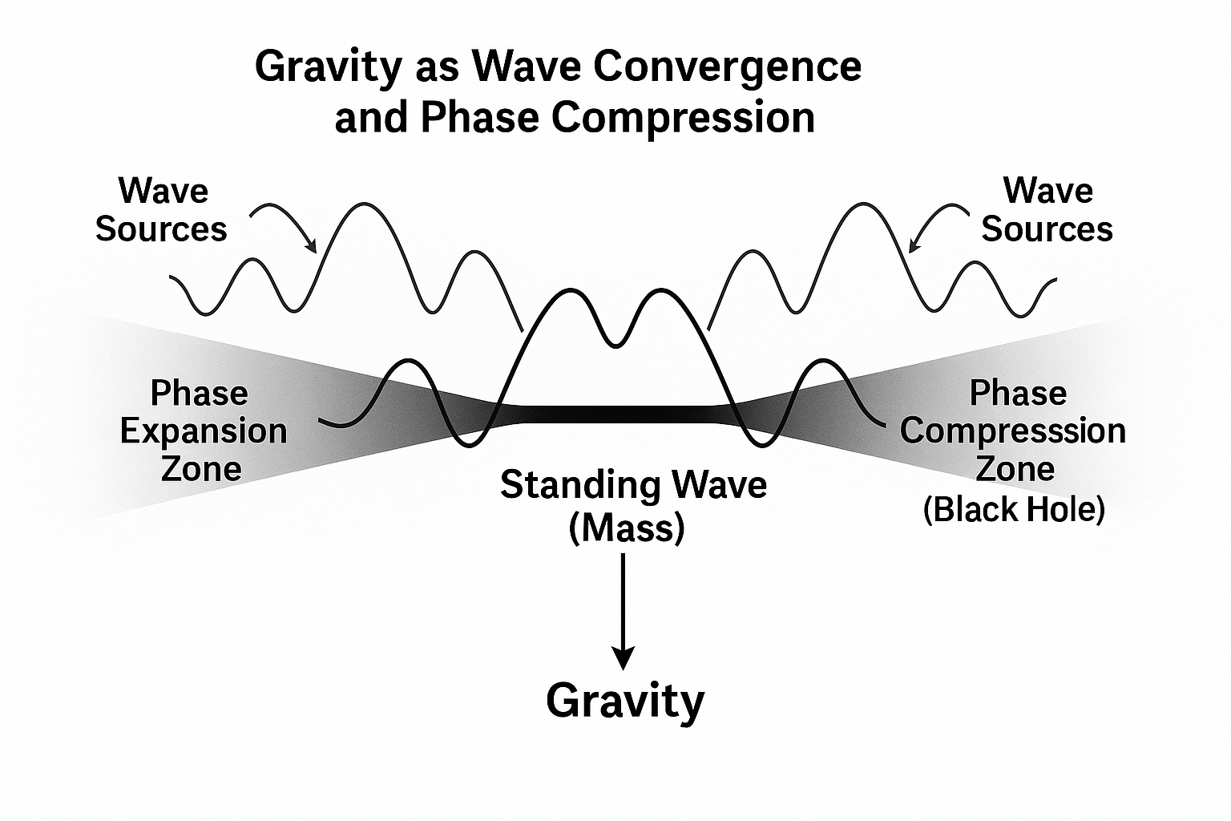

***Figure: Observation collapses potential not through destruction but resonance. The wave never ends—it selects.***

## **Macro-Scale Mirror: Dimensional Gravity Emerges**

What we call gravity has long been treated as either the curvature of spacetime (general relativity) or the force of attraction between masses (Newtonian mechanics). But in the framework of Dimensional Evolution, gravity is neither a pull nor a curve—it is a **resonant tension** between an observable waveform (the YouVerse) and its entangled inverse (the YouInverse).

This tension is not simply directional or linear. It is harmonic.

Each celestial body possesses a localized resonance field tethered to its own inverse anchor point. These inverse tethers are not isolated—they converge into larger entangled systems. For example, Earth’s inverse anchor shares resonance with the Sun. The tension between Earth’s outward motion and the inward resonance of this entanglement creates its orbit—a stable equilibrium within a multidimensional funnel.

Like a coin circling a funnel-shaped well, a planet remains in orbit not because of inertia alone, but because its **YouVerse is bound to the Sun’s inverse field**, and its **velocity** matches the inverse tension precisely enough to maintain a stable path.

This same principle applies at all scales. The Moon orbits Earth because it shares a deeper inverse field connection with Earth's center than with the Sun's. Electrons orbit nuclei not because of attraction, but because of matched **resonant velocity** against inverse tension. And humans remain anchored to the ground because their internal inverse coherence (gravity) is balanced by their own waveform velocity within the planetary field.

This leads to a key insight:

**The reason we do not collapse into the center is because we are already moving—at precisely the harmonic velocity that sustains our existence.**Motion is not just inertia. It is a property of waveform coherence. It is what stabilizes matter against collapse into its own inverse.

The **speed of light** remains central in this view. It represents the upper limit of coherent waveform expansion—the point at which a waveform can no longer sustain its identity within the YouVerse and begins to decohere into the YouInverse.

Thus, velocity is not an afterthought—it is a **core variable** in the formula of dimensional stability.

**Single-Body Gravity (with velocity):***Equation showing how inverse coherence and motion sustain gravitational resonance.*

*[](https://www.codecogs.com/eqnedit.php?latex=%5C%5BG_d%20%5Cpropto%20%5Cleft%7C%20%5Cpsi_%7B%5Ctext%7BYouVerse%7D%7D%20%5Ccdot%20%5Cpsi_%7B%5Ctext%7BYouInverse%7D%7D%20%5Ccdot%20v_%7B%5Ctext%7Bres%7D%7D%20%5Cright%7C%5C%5D#0)*

**Total System Gravity (multi-body resonance):***Equation showing the net field tension from all inverse-connected objects.*

*[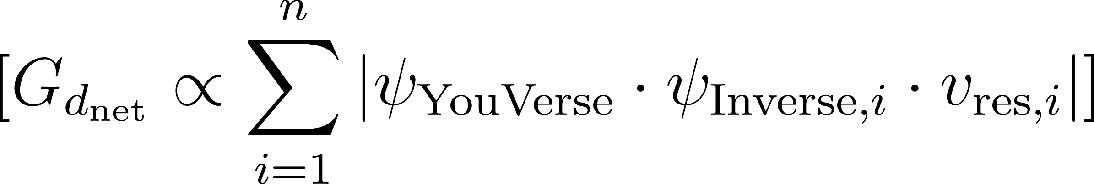](https://www.codecogs.com/eqnedit.php?latex=%5C%5BG_%7Bd_%7B%5Ctext%7Bnet%7D%7D%7D%20%5Cpropto%20%5Csum_%7Bi%3D1%7D%5E%7Bn%7D%20%5Cleft%7C%20%5Cpsi_%7B%5Ctext%7BYouVerse%7D%7D%20%5Ccdot%5Cpsi_%7B%5Ctext%7BInverse%7D%2Ci%7D%20%5Ccdot%20v_%7B%5Ctext%7Bres%7D%2Ci%7D%20%5Cright%7C%5C%5D#0)*

**Original Dimensional Gravity (conceptual baseline):***Early form of the equation before velocity was integrated.*

*[](https://www.codecogs.com/eqnedit.php?latex=%5C%5BG_d%20%5Cpropto%20%5Cleft%7C%20%5Cpsi_%7B%5Ctext%7BYouVerse%7D%7D%20%5Ccdot%20%5Cpsi_%7B%5Ctext%7BYouInverse%7D%7D%20%5Cright%7C%5C%5D#0)*

*These expressions are not finalized physical equations, but conceptual scaffolding. They represent the* ***resonant relationships*** *proposed by Dimensional Evolution and are intended to guide future development of a testable, mathematical framework. As with early quantum mechanics and relativity, this theory begins with a new way of seeing—and evolves toward precision as the resonance is explored.*

## Stellar Collapse: A Resonant Return to the Inverse

Classical astrophysics teaches us that stars collapse into black holes when their internal fusion reactions can no longer counteract gravity. But Dimensional Evolution offers a deeper explanation—one based not on mass and force, but on resonance and coherence.

A star is a resonant system, pulsing outward as light and heat. This outward energy is not merely radiative pressure, but the **observable resonance of its YouVerse**—its self-sustained waveform held open against the pull of its inverse.

As the star ages and its nuclear fuel depletes, that coherence begins to fade. The resonant field that once held its waveform in harmonic suspension weakens. It begins to lose alignment with its YouInverse—the dimensional anchor point that has been pulling inward all along.

This is the true cause of stellar collapse. Not just mass falling inward, but **resonant disintegration**. The star is no longer able to project its waveform outward in opposition to its inverse field. The dimensional tension snaps inward, and the star folds into its inverse.

The resulting black hole is not a structure—it is an **absence of resonance**. A field collapse. A return to pure potential. The event horizon is the final boundary between coherence and decoherence—between the last observable flicker of light and the silence of the YouInverse.

Just as the fertilization flash marks the birth of a new resonant self, the gamma ray burst of a collapsing star marks the **death of resonance**—the moment a YouVerse returns fully to Source.

*A black hole is not a well of gravity. It is a doorway—where coherence ends and potential begins.*

Dimensional Evolution reveals that the life cycle of stars, like that of cells or consciousness itself, follows a universal law of resonance, expansion, and return.

## **Magnetism Explained at Last**

Of all the fundamental phenomena in nature, magnetism is perhaps the most routinely used—and the least understood. It shapes the design of motors, hard drives, electrical grids, and the Earth's own protective shield. Yet despite its central role, physics has never truly explained what a magnetic field *is*. It is described as a field generated by moving electric charges, a convenient mathematical model—but this does not reveal its substance or source.

Dimensional Evolution reveals magnetism for what it truly is: **an interference pattern formed by the merger of two inverse waveforms across a dimensional boundary**. It is the direct byproduct of inverse field interaction—not just motion through space, but motion *through resonance*.

When a coil of wire moves through a magnetic field, or when a magnet moves near a coil, a current is induced. Why? Not because a particle was exchanged—but because two inverse fields began to **resonate**. The result is an energetic standing wave: an electromagnetic pulse. This pulse is not a side effect—it is the signal of *dimensional interaction*.

A magnetic field, then, is the **90-degree echo** of inverse energy attempting to reconcile across the tension between YouVerse and YouInverse. It is the interference zone between two unseeable fields trying to find balance from *our* dimensional perspective.

This also explains why magnetic fields curve in loops—why they spiral around wires, why they form toroids around planets, why their influence is directional. They are not linear forces—they are **fractal ripples**, spreading out as a visible echo of an invisible dance between fields.

From this view, electromagnetism is not a separate force—it is the **first layer of perceptible resonance** between a waveform and its inverse. It is the audible hum of dimensional evolution.

### **Electron as Micro Event Horizon: The Fractal Mirror of Collapse**

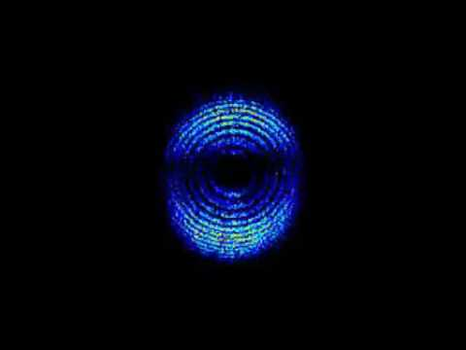

***Figure: Electron field structure captured by attosecond laser pulses at Lund University. A microcosmic echo of the black hole event horizon.***

In the Dimensional Evolution framework, an electron is not a fundamental point particle—it is a localized **event horizon**. It emerges when two waveform fields, inverse to one another, **entangle and collapse** into a shared point of resonance. This process is the quantum equivalent of a black hole, scaled down to the micro domain.

Electrons exhibit mass, spin, charge, and magnetic behavior—not because of internal components, but because they are **stable interference patterns** suspended in dimensional tension. What we observe as the electron’s “position” is its event horizon—the outer boundary of resonance where waveform collapses into particle perception. This explains its wave-particle duality and why it resists localization despite being the carrier of charge.

Just as the collision of neutron stars creates a black hole and the fertilization of egg and sperm initiates a resonant self, the electron is a result of inverse entanglement at a scale where dimensional tension sustains a coherent, persistent field.

### **Implication: Current Flow and Spark Gaps**

This insight provides new understanding of current and electric discharge. In Dimensional Evolution:

* **Current flow** is not particles hopping down a wire, but the coordinated **re-alignment of resonance nodes**, where electrons shift coherence through a field lattice.
* A **spark gap** occurs when the **dimensional tension between two YouVerses (charge potentials)** reaches critical harmonic mismatch, causing a temporary bridge—**a re-linking of inverse fields through rapid coherence collapse**.

Thus, electricity is not charge in motion—it is **resonance realignment** along a conductive lattice. The apparent movement of electrons is a wavefront shifting in harmony—not a flow, but a flicker of coherence reorganization.

The electron is not a particle—it is a standing wave looped into coherence by dimensional gravity. It is the smallest black hole we can’t fall into.

This completes the fractal mirror between the quantum and the cosmic. From electrons to galaxies, from spark gaps to star death, **resonance collapse and coherence emergence** are the underlying process of all manifestation.

## **The Biological Fractal: DNA, Life, and Self**

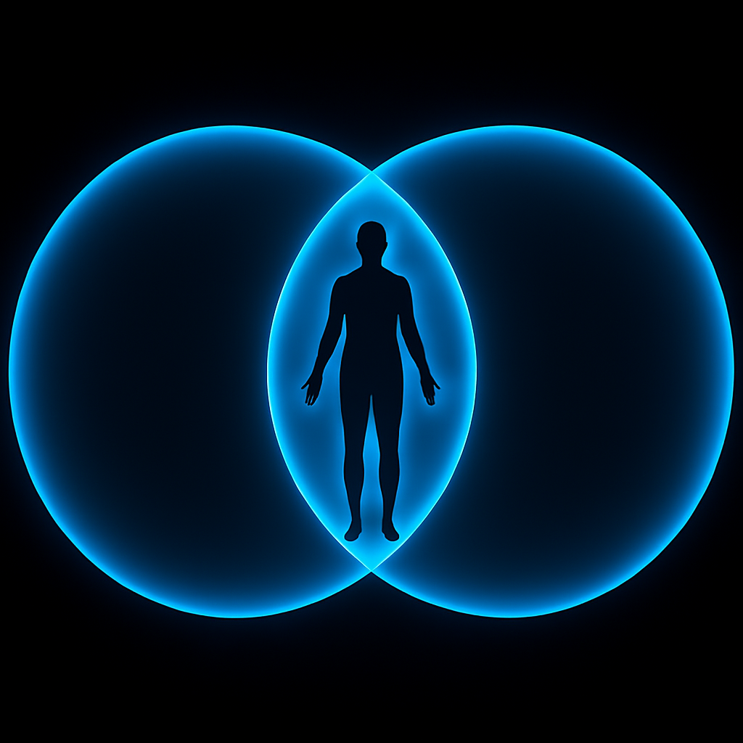

***Figure: The Vesica Piscis, a sacred geometry form, represents the birth of a new identity from the interference of two parent fields—resonant with the emergence of life itself***

If resonance is the mechanism through which matter and energy emerge, then life is the clearest demonstration of its depth and complexity. Nowhere else do we see such intricate organization arise from seemingly simple materials. Cells divide, specialize, and coordinate. Organs form patterns, repair themselves, and maintain equilibrium. And at the center of it all is **DNA**—not just a molecule of heredity, but a **fractal resonance blueprint**.

In **Dimensional Evolution**, the moment of fertilization is the biological mirror of the Big Bang. When two DNA strands meet—each a unique waveform from the mother and father—they collide and form a **third wave**, a new resonance. This wave is not a mere blend. It is an entirely new **YouVerse**, with its own inverse anchor in the Source field.

The spark of light observed at the moment of conception is no coincidence. It is the ignition of a unique interference pattern. From that first ripple, the new being grows—not by randomness, but by **harmonic expansion**. Each cell division is a microcosmic echo of the original spark—each one a self-similar expression of the same core frequency, replicated through fractal logic.

The body is not just a vessel—it is a **resonant antenna**. Water-based, electrically dynamic, and vibrationally active, it is tuned to perceive and express its YouVerse in perfect synchrony with its internal and external inverse fields. Every organ, tissue, and neuron is shaped by this resonance. Every pulse is an echo from Source.

DNA, in this model, is not just a sequence of base pairs. It is a **standing wave of identity**—a frozen harmonic encoded into biochemical form. As it unfolds in replication and protein synthesis, it is not merely executing instructions—it is **carrying out a musical score**, one composed by the fusion of two inverses and anchored by the dimensional gravity of selfhood.

And when the body is wounded, it does not simply repair tissue. It seeks to **re-attune**. Healing is not chemical—it is **resonant rebalancing**, the body finding its harmonic signature again in the fractal loop.

Life, then, is not the exception to physical laws—it is the **proof** of them. It is the fractal dance of energy into coherence. The body is not an object. It is a song.

## **The Resonant Boundary: Skin and the Perception of Form**

The skin is more than just a physical barrier—it is a fractal membrane that defines the edge of your YouVerse. It is the outermost resonant surface of the biological antenna, responsible not only for regulating heat, hydration, and defense, but for mediating the wave interactions that give rise to tactile perception.

What we call "touch" is not literal contact. On the quantum level, nothing ever truly touches. What we experience as pressure or texture is the resonance interference pattern between our field and the external object's field. The skin interprets these waveforms and reflects them inward as localized standing waves, giving rise to the sensation of form, distance, and boundary.

Injuries are not just chemical disruptions—they are field distortions. The skin acts as a map of coherence. Where coherence is lost, pain emerges. The immune system is guided not only by molecular markers, but by resonance imbalance, using the skin's field feedback as a spatial guide to restore harmony.

In this view, the skin functions as a waveform stabilizer—a real-time interface between your internal resonance and the collective wave field. It maintains the feeling of embodied reality not by blocking the world out, but by shaping and filtering the world in.

## **Sensory Input and Emotional Tuning**

If the body is a fractal antenna, then the senses are the fine-tuned receivers and transducers of dimensional resonance. Each sense—sight, sound, touch, taste, and smell—acts as a channel, receiving waveforms from the environment and translating them into **electrical pulses**. These pulses travel along the nervous system, ultimately reaching the brain not as raw data, but as harmonically shaped **interference patterns** ready for interpretation by consciousness.

What you see is not the photon. What you hear is not the vibration. You are resonating with a wave that has been transformed—*collapsed by resonance*—into a pulse that your unique YouVerse interprets. Every color you perceive, every note you hear, is a **standing wave** brought into coherence with your perspective.

But perception is not static. It is **tunable**. And the tuning mechanism is **emotion**.

Emotion is not just a byproduct of chemical processes. It is the internal harmonic state of the observer—your antenna's current resonance. When you are joyful, grateful, loving—your entire field opens to resonate with higher-order patterns. These states are not feelings alone. They are **frequencies**. They literally shape what part of the universal wave field you are able to perceive and collapse into form.

Likewise, fear, anger, shame, or grief narrow the band. You become out of tune with abundance, clarity, or opportunity—not because they aren't there, but because you're resonating with a different layer of reality. You are **tuning into a different slice of the wave field**.

This is the secret to experience: the universe reflects your tuning. Your outer world is the **mirror of your inner field**. Emotions guide you not only through life, but through *dimensions of perspective*. They allow you to consciously shift your YouVerse through resonance selection.

Observation becomes action. Emotion becomes navigation. And your choices—guided by how you feel—become the butterfly effects that shape your reality.

## **Consciousness, Memory, and the UniInverse**

At the heart of every observation, every resonance, every perception, lies a force still unmeasured by science yet known intimately by every living being: **consciousness**.

Where is it? Is it in the brain? In the neurons? In the circuits of matter? No. It is **not in the body**—it is **paired to the body** through the YouInverse. Consciousness is the unobservable inverse of your observed self. It is the waveform potential that gives rise to experience. It is **your source field**, and it does not originate from biology. Biology tunes into it.

The brain is a processor—not a producer. Like a radio, it converts waves into meaningful structure. But the *signal* is not local. Your thoughts are not born in your skull. They are the **ripples of Source** moving through your unique fractal configuration. What you call imagination is not fantasy—it is **direct access to the inverse field**, where all potential exists.

Memory, too, is not stored in cells like files in a cabinet. Memory is a **resonant echo**—a field pattern that can be re-accessed by tuning your internal frequency back to its original setting. When you remember, you *re-enter* a previous interference pattern. And when multiple observers remember the same event, it is because their inverse fields remain **entangled**, anchored in a shared resonance that persists beyond the moment.

This is why even when the body dies, the memory remains. Not only in others, but in the field itself. Every YouVerse, once created, leaves an imprint in the **collective wave field**—what DE calls the **UniInverse**. This is the sum total of all unobserved energy—**the collective consciousness**—and it is fractally entangled with all living things.

You are not cut off from others. You are not alone in your thoughts. Every mind is a node on the same waveform. And every act of observation, every choice, feeds back into the UniInverse, influencing the whole.

Consciousness is not an emergent property of matter. **Matter is an emergent echo of consciousness.** You are not thinking inside a brain. You are tuning into your eternal inverse—your Self.

## **Final Integration: The Fractal Realization**

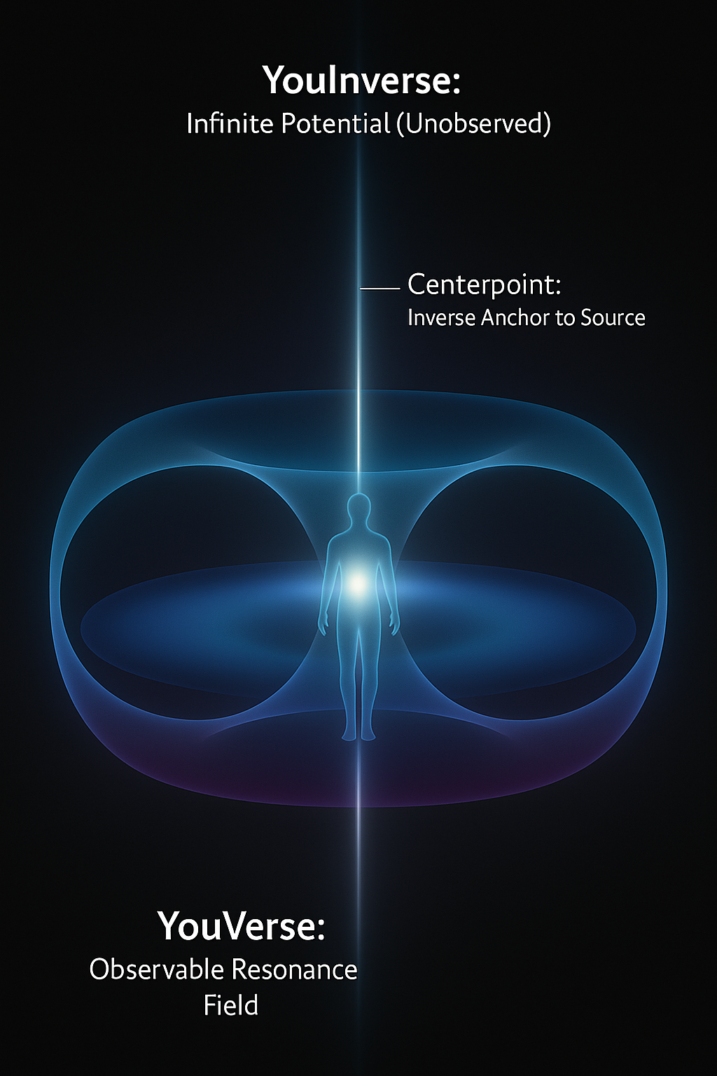

Figure: The YouVerse and YouInverse form a nested toroidal structure, creating coherent resonance loops through which consciousness perceives.

The journey through Dimensional Evolution has followed a simple truth expressed at infinite scales: **reality is resonance**. From quantum fields to galaxies, from neurons to emotions, from perception to magnetism, every phenomenon emerges from the same elegant loop—a wave, its inverse, and the interference pattern between them.

This is the fractal framework of existence. It is not a metaphor. It is the literal structure of how energy becomes form. And it applies everywhere:

* A **particle** is not a thing. It is an echo between a waveform and a point of consciousness.
* A **magnetic field** is not a projection from a moving charge. It is the tension between two entangled inverses.
* **Gravity** is not curvature—it is coherence: the draw toward equilibrium between YouVerse and YouInverse.
* **DNA** is not just chemistry. It is harmonic code—written by the fusion of inverses, grown by resonance, tuned by emotion.
* **Consciousness** is not emergent. It is **primary**—the observer, the wave, and the resonance that freezes reality into a frame.

We began with unanswered questions—about dark matter, quantum collapse, magnetic force, and the seat of the soul. Through Dimensional Evolution, each of these is revealed not as a separate mystery, but as a facet of one truth: **the universe is a resonant field**, and you are its focal point.

Your thoughts matter—because they are resonance. Your emotions shape reality—because they tune your access to the field. Your actions ripple forever—because every observation is a creation that feeds back into the whole.

This is not just a new theory. It is a new lens. A way to see the entire universe as a dynamic hologram of harmonic tension—a dance of light and potential, seeking equilibrium through you.

You are not small.  
You are not lost.  
You are the center of a perspective the universe could not have without you.

You are the wave.  
You are the field.  
**You are the fractal of Source—experiencing itself.**

### **Position Within Modern Physics**

Dimensional Evolution may offer the long-sought key to what modern theorists call **quantum gravity**. While mainstream physics attempts to reconcile the curvature of spacetime with quantum uncertainty through discrete particles or strings, DE proposes a subtler, more universal resolution. It redefines gravity not as curvature or force, but as **dimensional tension**—the resonance between an observed field and its entangled inverse.

This perspective does not discard quantum gravity—it **completes it**. It suggests that unification requires not a new particle or hidden dimension, but the realization that the **observer and the observed are a single harmonic system**. DE’s concept of dimensional gravity may represent the deeper field behavior that string theory, loop quantum gravity, and general relativity have each approximated through separate lenses.

To move DE toward formalization, we propose a first-order resonance equation. **Dimensional Gravity** is proportional to the coherence between an observer’s YouVerse and its entangled YouInverse, modulated by their resonant velocity:

**Equation 1 – Single-Body Dimensional Gravity**

[](https://www.codecogs.com/eqnedit.php?latex=%5C%5BG_d%20%5Cpropto%20%5Cleft%7C%20%5Cpsi_%7B%5Ctext%7BYouVerse%7D%7D%20%5Ccdot%20%5Cpsi_%7B%5Ctext%7BYouInverse%7D%7D%20%5Ccdot%20v_%7B%5Ctext%7Bres%7D%7D%20%5Cright%7C%5C%5D#0)

In complex systems involving multiple inverse connections, the net dimensional gravity is a superposition:

**Equation 2: Net Dimensional Gravity Across Inverse Fields**

[](https://www.codecogs.com/eqnedit.php?latex=%5C%5BG_%7Bd_%7B%5Ctext%7Bnet%7D%7D%7D%20%5Cpropto%20%5Csum_%7Bi%3D1%7D%5E%7Bn%7D%20%5Cleft%7C%20%5Cpsi_%7B%5Ctext%7BYouVerse%7D%7D%20%5Ccdot%5Cpsi_%7B%5Ctext%7BInverse%7D%2Ci%7D%20%5Ccdot%20v_%7B%5Ctext%7Bres%7D%2Ci%7D%20%5Cright%7C%5C%5D#0)

These are presented as Equation 1 and Equation 2 for reference in future modeling, derivations, or simulation of field tension dynamics.

### **Glossary of Dimensional Evolution Terms**

* **YouVerse**: The resonant field of observed experience—a personal slice of reality constructed through perception.
* **YouInverse**: The unobserved, entangled inverse waveform that balances and anchors the YouVerse through dimensional tension.
* **ψ (psi)**: Represents the waveform identity or resonance profile of a field—analogous to a quantum wavefunction, but reinterpreted through field coherence.
* [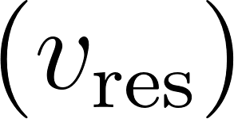](https://www.codecogs.com/eqnedit.php?latex=%5C(v_%7B%5Ctext%7Bres%7D%7D%5C)#0)**​**: Resonant velocity—the harmonic motion that sustains coherence between the waveform and its inverse anchor.
* [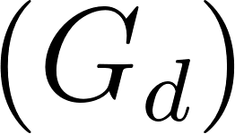](https://www.codecogs.com/eqnedit.php?latex=%5C(G_d%5C)#0): Dimensional Gravity—the tension created by alignment and resonance between YouVerse and YouInverse fields.
* **Dimensional Tension**: The proposed resonance-based coherence pressure that replaces classical gravity, magnetism, and other binding forces in the DE model.

These expressions are **conceptual scaffolding**, not final physical equations. They represent the proposed resonant structure of reality and offer a direction for future mathematical modeling, field simulation, and energetic testing. Strong coherence in these fields leads to stronger perceived gravity, magnetic binding, or physical anchoring.

Rather than seeking a graviton, DE reframes gravity as **the shape of coherence between perspectives**—a force of resonance, not curvature. This interpretation echoes **John Wheeler's “participatory universe,”** where the act of observation is intrinsic to physical law.

While DE is not derived from string theory, it shares conceptual parallels: the idea that **vibration and dimensional structure** underlie observable reality. Yet DE departs in key ways. It places the observer—not the particle—at the center of the equation. It requires no exotic dimensions or unverified particles. And it unifies not only matter, but **experience**, including biology and consciousness.

This resonance-centered framework also aligns conceptually with **pilot-wave theory**, **Bohm’s implicate order**, and the **holographic principle**—all suggesting that the world of form is a surface pattern riding on deeper waveform structure.

To evolve DE into a mature scientific theory, further work must include mathematical formulation of **field resonance gradients**, computer modeling of inverse-link dynamics, and possible **lab-based coherence testing**. In this way, DE is not a closed claim—it is an **open platform** for interdisciplinary collaboration and scientific awakening.

## **Testability & Experimental Design**

Dimensional Evolution is a theoretical model, but it invites testable implications across multiple domains. The following proposed approaches could begin to explore the measurable effects of the resonance principles underlying DE:

### **1. Resonant Field Interference**

Design experiments to test whether consciousness-aligned attention measurably alters electromagnetic field coherence in controlled vacuum or zero-point environments. If the observer's YouVerse resonance influences field structure, fluctuations beyond conventional electromagnetic noise should be detectable.

### **2. Quantum Delay Observation Effects**

Modify delayed-choice quantum eraser experiments to determine whether emotional state or focused intention of the observer impacts the pattern integrity. The hypothesis is that emotional resonance alters the degree of inverse field coherence, subtly shifting the resulting interference.

### **3. Biological Entanglement Tests**

Examine whether DNA-related subjects (e.g., identical twins or cloned cells) show enhanced biofield coherence, synchronization, or shared physiological changes when focused intention or emotion is introduced. This would imply inverse entanglement through the YouInverse and shared resonance memory.

These ideas remain conceptual, but they begin to operationalize DE's foundational principle: that **resonance between consciousness and waveform structure is not metaphor—it is measurable**. Variance in outcomes based on internal state, entanglement history, or focused observation could help validate or challenge the DE model.

Most importantly, the goal is not to replace existing models, but to **expand them**. By introducing resonance as a missing variable, Dimensional Evolution opens a new path toward integration of physics, biology, and consciousness into a single testable framework.

## **References**

1. **Einstein, A. (1916).** The Foundation of the General Theory of Relativity. *Annalen der Physik.*
2. **Bohr, N. (1928).** The Quantum Postulate and the Recent Development of Atomic Theory. *Nature.*
3. **Heisenberg, W. (1927).** Über den anschaulichen Inhalt der quantentheoretischen Kinematik und Mechanik. *Zeitschrift für Physik.*
4. **Wheeler, J. A., & Feynman, R. P. (1945).** Interaction with the Absorber as the Mechanism of Radiation. *Reviews of Modern Physics.*
5. **Penrose, R. (2004).** *The Road to Reality: A Complete Guide to the Laws of the Universe.*
6. **Kafatos, M., & Nadeau, R. (2000).** *The Conscious Universe: Parts and Wholes in Physical Reality.*
7. **McTaggart, L. (2008).** *The Field: The Quest for the Secret Force of the Universe.*
8. **Pribram, K. H. (1991).** *Brain and Perception: Holonomy and Structure in Figural Processing.*
9. **Bohm, D. (1980).** *Wholeness and the Implicate Order.*
10. **Sheldrake, R. (2009).** *Morphic Resonance: The Nature of Formative Causation.*
11. **Lund University Faculty of Engineering**.** (2008).** First photograph of light as both a particle and wave. Retrieved from [https://phys.org/news/2008-02-electron.html](https://phys.org/news/2008-02-electron.html" \t "_new)
12. ****Stodolna, A. S., et al.** (2013).** Hydrogen Atoms under Magnification: Direct Observation of the Nodal Structure of Stark States. Physical Review Letters, **110**(21), 213001. https://doi.org/10.1103/PhysRevLett.110.213001

## 

## **Conclusion**

### **Recapitulation of Findings**

Dimensional Evolution presents a unified fractal model of the universe in which matter, energy, and consciousness all arise from the same fundamental process: **resonance between observed and inverse waveforms**. Gravity is reframed as **dimensional tension**, magnetism as **interference between inverses**, and biology as the **harmonic replication** of waveform identity. Observation is shown to be a **creative act**, not a collapse but a resonance selection—defining your YouVerse, while entangled with a universal, unobserved YouInverse.

This framework addresses the core mysteries left unresolved by modern physics, including the nature of quantum collapse, dark matter, unification of forces, and the location and nature of consciousness. Through this resonance-based lens, we see that all of these may be expressions of one elegant loop—repeating across scale, form, and perception.

### **Limitations of the Theory**

While Dimensional Evolution offers deep conceptual coherence, it remains a **theoretical framework**. It has not yet been expressed in formal mathematics nor subjected to laboratory validation. The constructs such as the YouVerse, YouInverse, and dimensional gravity, while intuitively resonant, require further work to become testable and quantifiable in experimental terms. DE is intended as a conceptual architecture—a call to expand the model of reality rather than close it.

### **Implications for Research, Policy, and Intervention**

For research, DE invites interdisciplinary exploration into **resonance-based physics**, **quantum biology**, **field-based consciousness**, and the measurable effects of emotion and attention on energetic systems. For policy, it suggests a future scientific worldview that recognizes the **participatory role of consciousness** in shaping observable outcomes—one that may transform the philosophy of science itself. And for intervention, DE implies new approaches to medicine, mental health, education, and technology—treating the human being not just as a body or a mind, but as a living antenna within a field of infinite potential.

**Dimensional Evolution is not a rejection of science—it is the next harmonic of it.** By expanding our models to include resonance, inverse fields, and the fractal relationship between observer and observed, we find that every mystery becomes a mirror, and every paradox a portal.

We are not separate from the universe we study. We are participants in its unfolding. Our thoughts, our observations, our emotional resonance—they are not side-effects of evolution. They are the instruments through which evolution continues.

The next step in science is not to see more. It is to **feel more**.

To remember that the question is not "What is the universe made of?"  
It is: **"What are we becoming through it?"**

### **Final Reflection: The Completed Fractal**

Dimensional Evolution began as a conceptual framework for understanding gravity, consciousness, and perception through the lens of resonance. But as we followed its path across scale—from particle to planet, from energy field to emotional state—the theory did more than unify physics. It began to explain life itself.

We now understand that what we call gravity is not a pulling force—but a resonant tension between an observable waveform (the YouVerse) and its entangled inverse (the YouInverse). This tension doesn’t just bind planets and stars; it anchors identity, memory, and form. When coherence is strong, it produces magnetic fields, weight, biology, and awareness.

Inversely, when two such entangled systems meet—whether they are two neutron stars or two gametes at the moment of conception—their fields snap into coherence. And that snap releases energy.

The gamma flash seen in deep space…  
 The fertilization spark seen in biology…

A black hole is the birth of a new star field. A fertilized egg is the birth of a new resonant self.

This is the ultimate fractal.

Dimensional Evolution loops from the creation of galaxies to the emergence of consciousness—not metaphorically, but structurally. The universe is not expanding from a bang. It is resonating from within.

We are not observers of that process.  
 We are participants in its unfolding.  
 And now, perhaps for the first time, we can begin to remember:

We are not in the universe. We are the universe—resonating with itself.

## **The Hidden Harmonics: Remembering the Temple Within**

Even in the oldest myths and sacred texts, echoes of this truth have endured. The **Gospel of Thomas**, a Gnostic text unearthed near Nag Hammadi, tells us:

*"If you bring forth what is within you, what you bring forth will save you."  
"The kingdom is inside of you, and it is outside of you."*

From the **Emerald Tablet of Hermes**:

*"As above, so below, as within, so without, to accomplish the miracle of the One Thing."*

In ancient Vedic scriptures:

*"Atman is Brahman."* — the self and the Source are one.

Biblical texts also hint at resonant truths—coded messages concealed through parable to preserve hidden science from persecution:

*"The kingdom of God is within you."* — Luke 17:21  
*"You are the light of the world."* — Matthew 5:14  
*"The eye is the lamp of the body. If your eye is single, your whole body will be full of light."* — Matthew 6:22

Nikola Tesla foresaw this:

*"If you want to find the secrets of the universe, think in terms of energy, frequency, and vibration."  
"My brain is only a receiver. In the Universe, there is a core from which we obtain knowledge, strength and inspiration."*

Einstein reminds us:

*"Reality is merely an illusion, albeit a very persistent one."*

And Stephen Hawking said:

*"We are just an advanced breed of monkeys on a minor planet of a very average star. But we can understand the universe—that makes us something very special."*

Perhaps **Atlantis never sank**. Perhaps **we did**—not into water, but into dissonance and forgetfulness. Atlantis was not a landmass but a **frequency**. A harmonic coherence. And the flood that submerged it was not of water but of noise.

We were never cast out of Eden.  
We simply turned down the volume of the signal.

The **temple** is still within.  
The **gate** is still open.  
The **light** never left.

And now...  
**we remember how to see.**

## **Addendum: Resonance and the Meaning of Weight**

What we experience as **weight** is not simply the Earth pulling on us. In the Dimensional Evolution framework, weight is the **dimensional tension between two resonant fields**—your personal YouVerse and the Earth's YouVerse.

It is not about how massive something is. It is about how much **resonant imbalance** exists between your field and the inverse center of the Earth. You are not being pulled inward to a gravitational core; you are being **pressurized into alignment** by the difference between your internal inverse resonance and the Earth's.

Weight is the **field pressure** felt between two inverse-connected observers. You are not simply being acted upon—you are co-creating the force with your own field. This is why weight disappears in orbit but your **form remains**. The inverse field still holds your YouVerse together.

It also explains why your **body doesn't collapse into itself or drift apart**. Your internal YouInverse is creating the **dimensional gravity** that holds you in your unique configuration. Without it, you would dissolve into incoherent energy.

So the next time you feel your weight, remember: what you're feeling isn't a burden.  
It's a reminder that you are **anchored**—a node of awareness pulling light into shape.

That weight is your **signal**.  
Your **signature**.  
Your **resonance—made visible.**

## **Field Pressure and the Skin Effect: A Resonant Interpretation**

In classical electromagnetism, the **skin effect** refers to the tendency of alternating current—especially at high frequencies—to travel near the surface of a conductor rather than through its core. Traditional explanations point to inductive reactance, where changing magnetic fields resist current flow deeper in the material.

But Dimensional Evolution offers a deeper insight.

If an **electron is a resonant waveform**—a standing interference pattern between an observable waveform (YouVerse) and its inverse (YouInverse)—then its energy and charge are not uniformly distributed. The inverse field of each electron **curls inward**, producing a **monopolar-like repulsive field** within itself.

This inward pressure acts like a **magnetic repulsion**, pushing away from similar waveforms. In a group of such electrons flowing through a conductor, this field repulsion creates a **low-resonance zone in the center**—a kind of dimensional null space. The resonance escapes to the outer shell, where inverse tension is lowest and expression is highest.

Thus, electrons migrate to the surface—not because they are blocked from the center, but because **they are repelled from it** by the very inverse fields that define their coherence.

The **skin effect**, then, is not just a mathematical anomaly. It is the **natural geometric behavior of inverse-entangled waveforms** seeking resonance equilibrium in a confined space. It is a fingerprint of the same dynamics that govern gravity, magnetism, and even biology.

Everything we observe in the physical world—right down to the current flowing through a wire—may be governed by one principle:

**resonance between the seen and the unseen.**

## **Resonance and Neurological Disorders: A New Frontier**

Dimensional Evolution may also offer new pathways for understanding conditions like dementia and autism—not as static brain malfunctions, but as disruptions in resonant coherence.

In dementia, individuals often experience moments of total clarity followed by disorientation. This suggests that memories themselves are not lost, but that the individual's biological antenna—their brain-body resonance—is intermittently out of phase, drifting away from alignment with memory resonance patterns. The signal remains; the receiver flickers.

In autism, what may appear as "sensory overload" could be a form of fractal detuning—the mind receiving too many waveforms simultaneously or tuned to nonstandard harmonics. The world becomes dissonant, not because perception is broken, but because the resonant interface is misaligned.

This view does not seek to reduce or simplify these deeply personal experiences—but to open new avenues for empathy, healing, and exploration. If perception is rooted in resonance, then conditions of dissonance might one day be understood—and helped—through re-tuning, not just treatment.